ODATA CRUD - Query – Operations

SE11 -> Choose Data type->Structure ZTRUPEN_S_ODATA_MAT_BASIC.
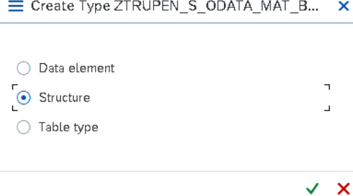\
Create the Structure with following fields.
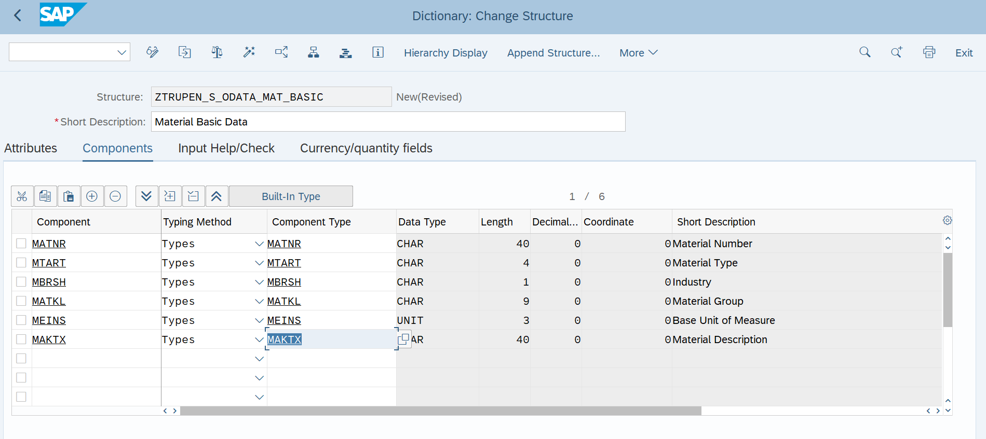
Save and activate the Structure.
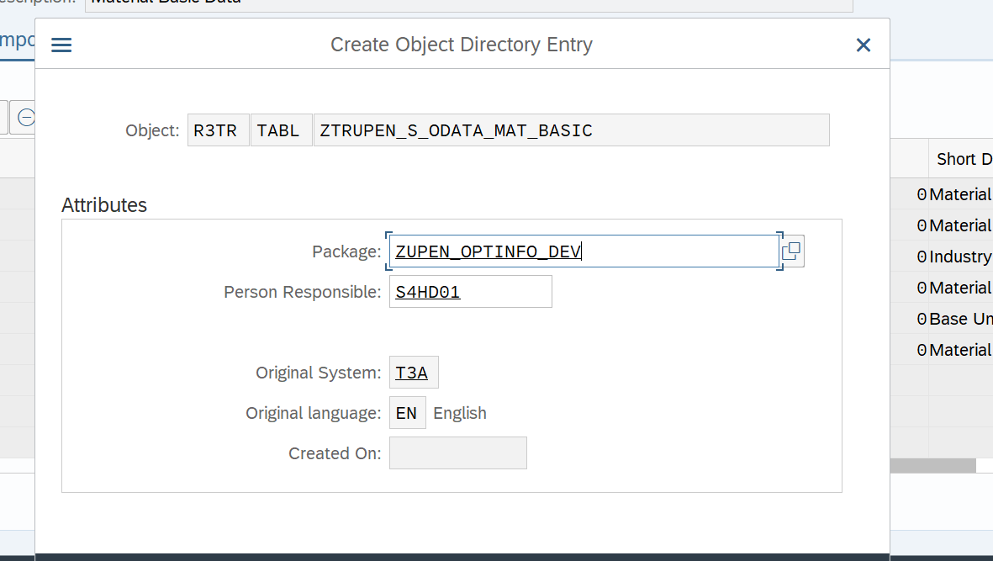
GATEWAY SERVICE BUILDER
Open SEGW Transaction and Click on Create Button for the Gateway Service Creation.
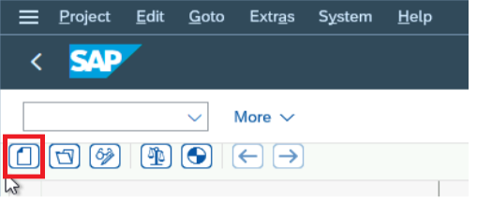
Now Provide the Project name, Description, Project type and Package for Service creation.

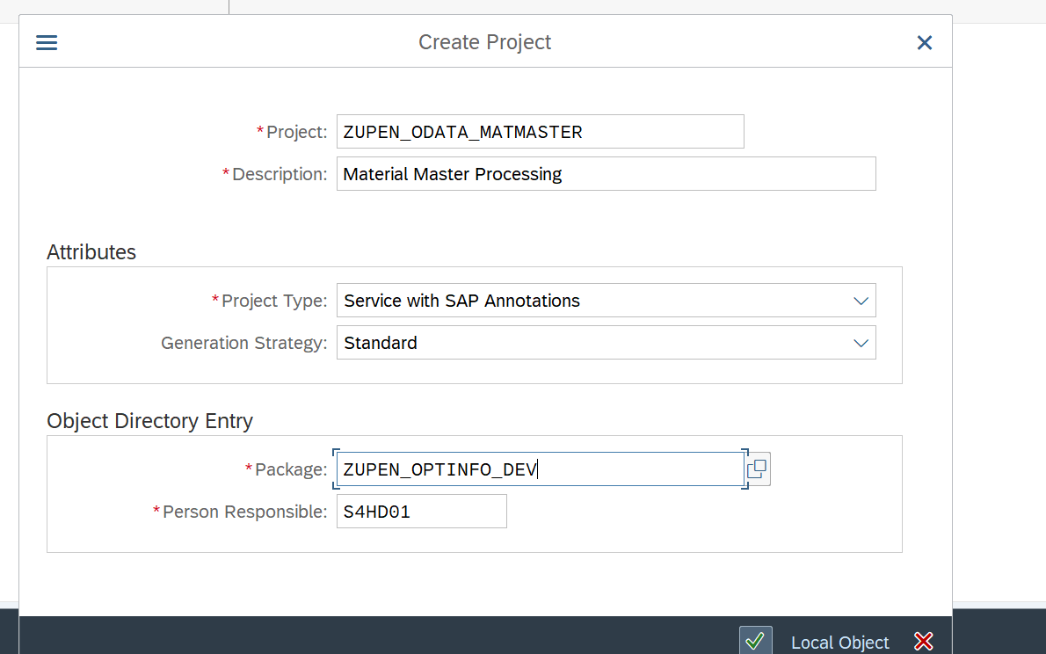
Click on Enter and the below screen will appear.
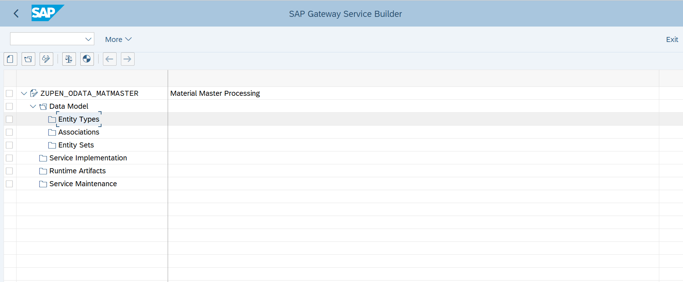
Right Click on the Data Model and Click on import->DDIC Structure
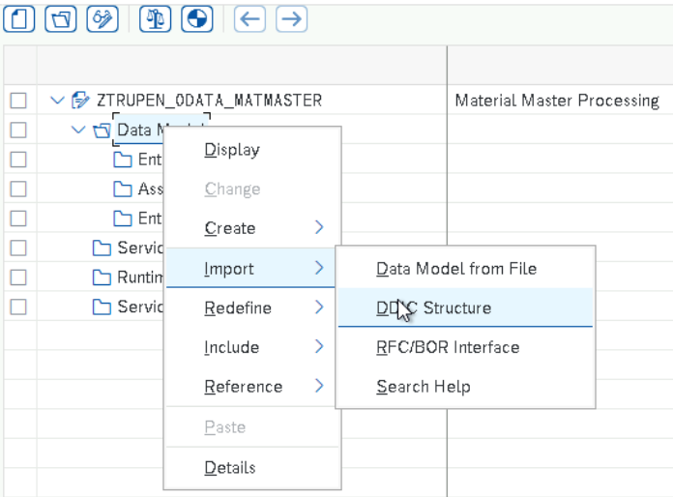
Now Provide the Name and choose type as Entity Type and Pass the Created Structure in the ABAP Structure and Click on Next.
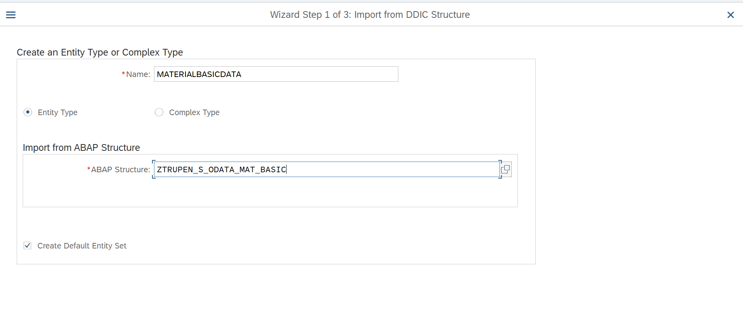
Now Select all the Fields and click on next to add the Field list in to the Entity.
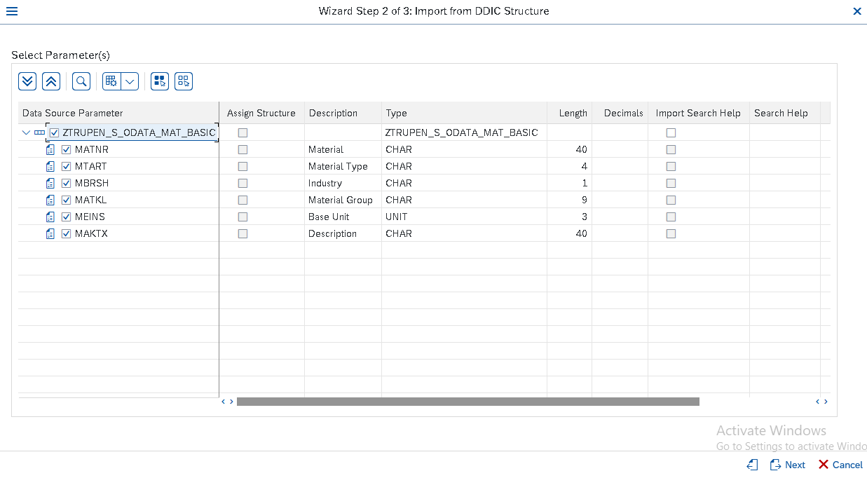
Now Check the Required key fields among the Field selected for the Entity type and Click on Finish.
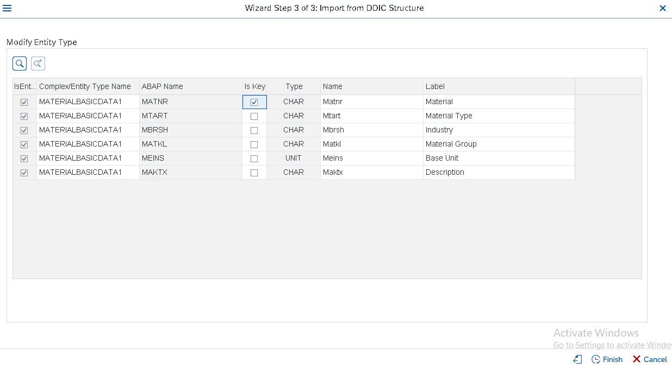
Now the Entity and Entity set is created automatically along with the fields selected in the Entity.
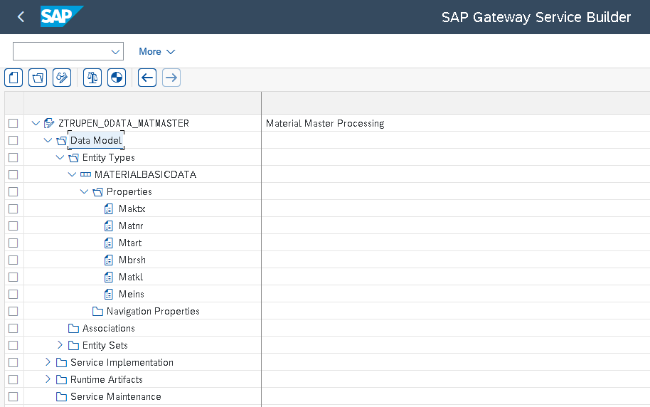
Now Click on generate Runtime Objects to generate the Model Class and Data Provider class and Model provider class.
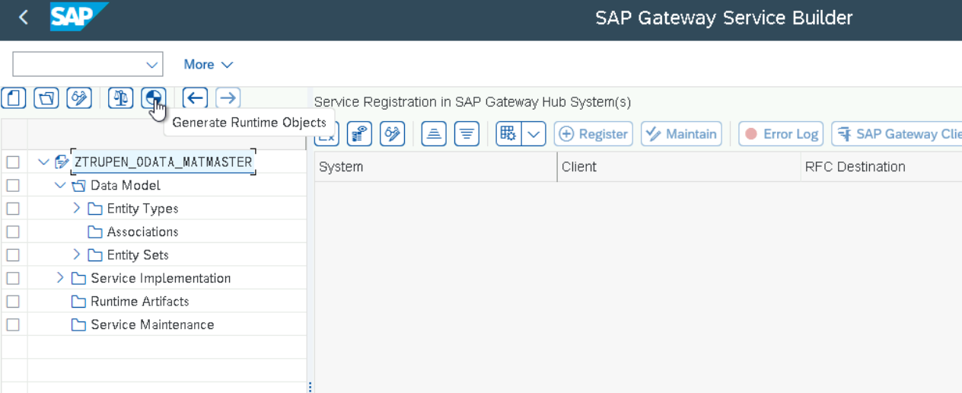
Provide the Transport and Click on Enter.

Now Modify the Class name, Model name and service name according to the Naming Conventions and click on Enter.
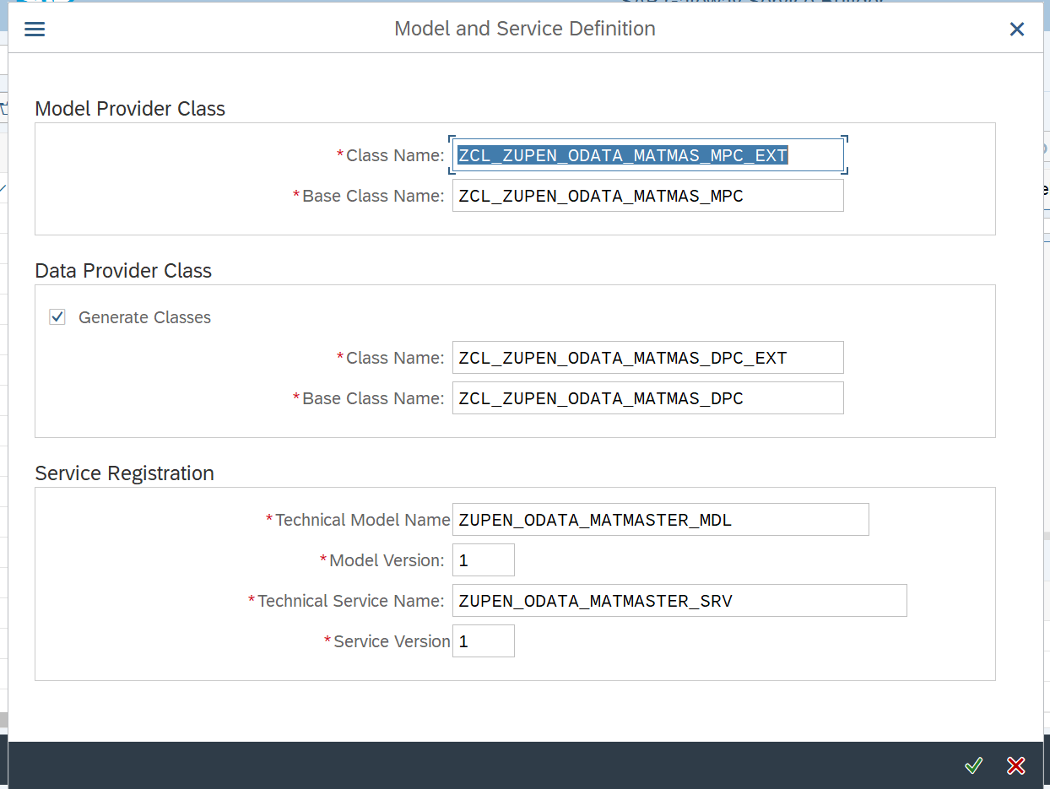
Now Provide the Package Name and click on Save.
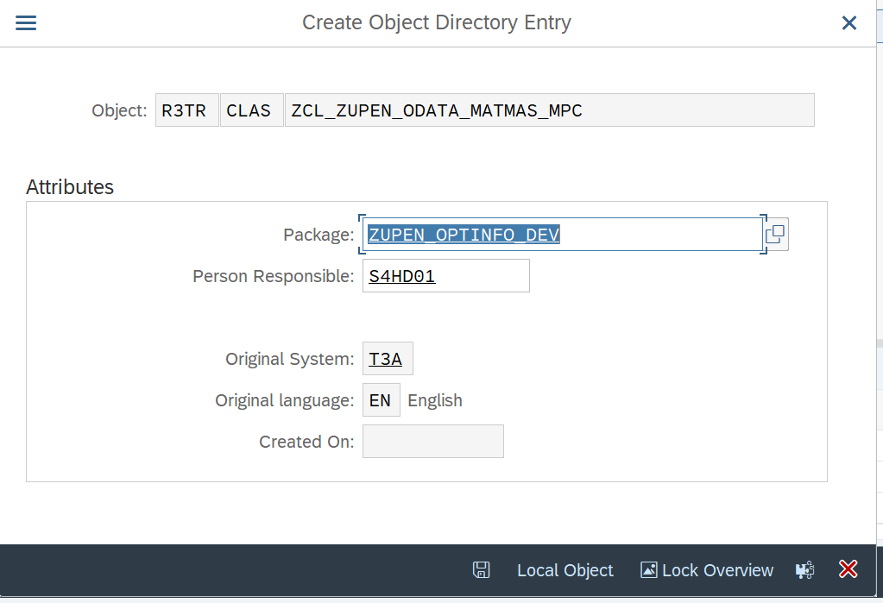
Now provide the transport and save.
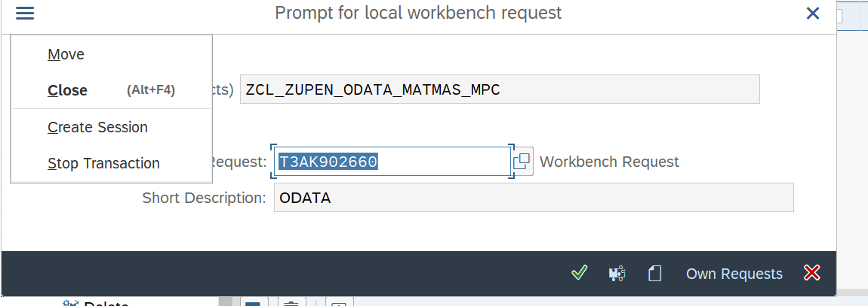
Now the Runtime Object are created and now we need to redefine the methods of data provide class to Perform the CRUD Operation.
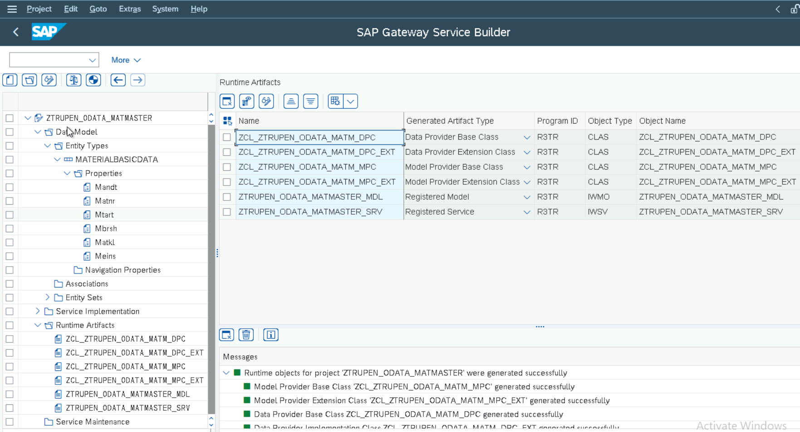
Now Double Click on the ZCL_ZTRUPEN_ODATA_MATM_DPC_EXT Class and Expand the methods->Inherited Methods and then we can redefine the method to write the Logic for Creating material Master in the method MATERIALBASICDAT_CREATE_ENTITY. Right Click on the Method where we need to redefine the Logic. we can redefine the other methods MATERIALBASICDAT_DELETE_ENTITY to set the Deletion Indicator and MATERIALBASICDAT_GET_ENTITY to select the data from the Material Master and MATERIALBASICDAT_UPDATE_ENTITY to update the Material Master.
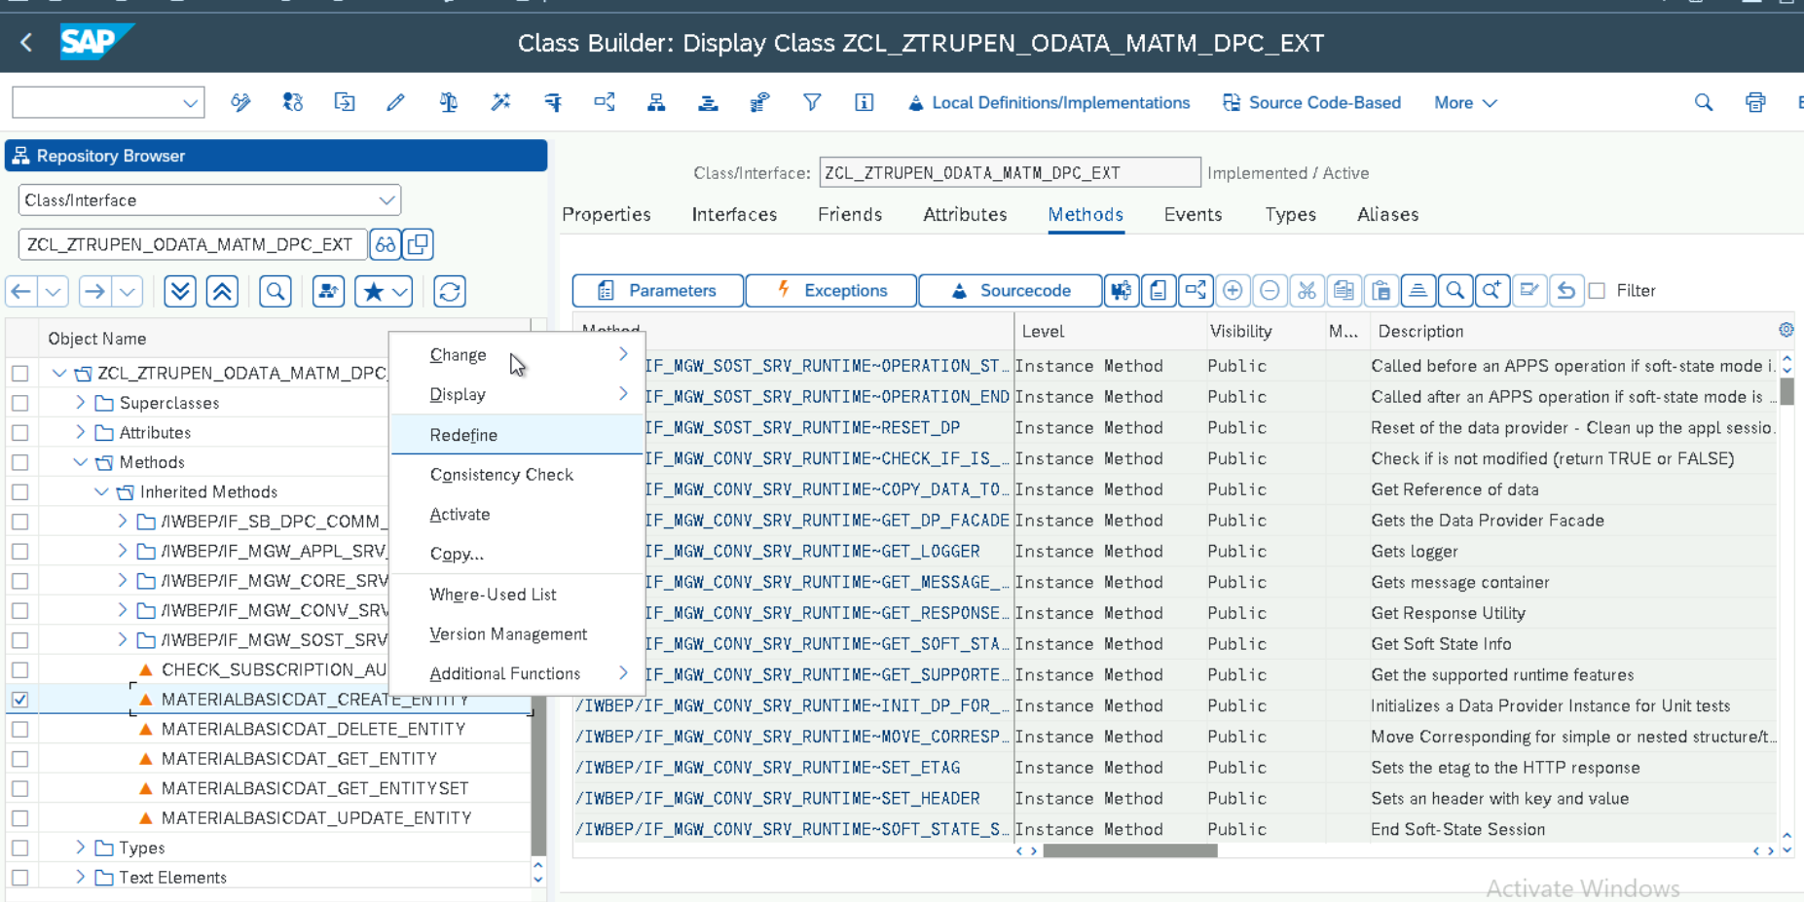
Now the Method can be seen under Redefinitions and we can write our own logic to perform POST or PUT or DELETE or GET Operations by implementing the redefined method.
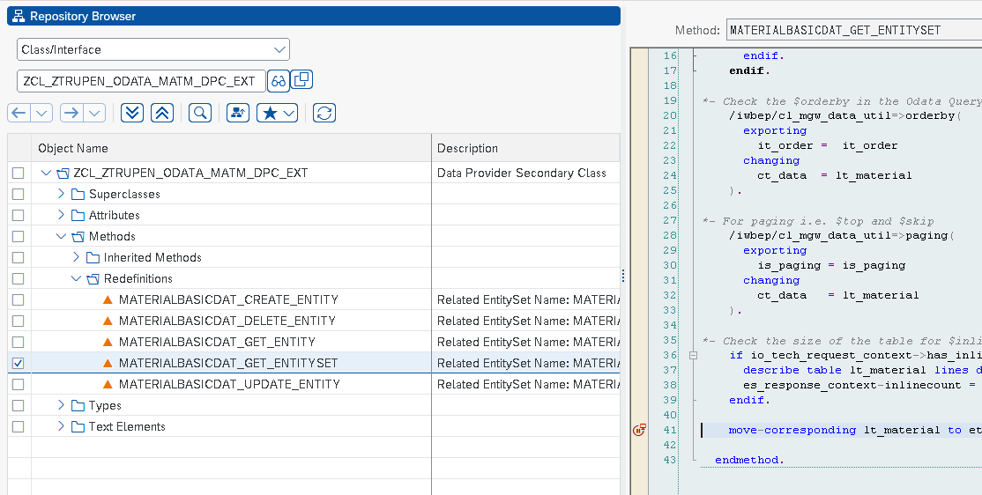
Custom implementation for ODATA Queries
MATERIALBASICDAT_GET_ENTITYSET can be redefined for the Querying option to handle the Filter query,Filter Query, Orderby Query ,Top and Skip Query,
Redefined method Logic
Create – POST Call
method materialbasicdat_create_entity.
data : lo_message_container TYPE REF TO /iwbep/if_message_container,
ls_matbasicdata type zcl_zupen_odata_matm_mpc=>ts_materialbasicdata,
ls_bapimathead type bapimathead,
ls_bapimara type bapi_mara,
ls_bapimarax type BAPI_MARAx,
lt_makt type standard table of bapi_makt,
ls_makt type bapi_makt,
ls_return type bapiret2.
io_data_provider->read_entry_data( importing es_data = ls_matbasicdata ).
ls_bapimathead-basic_view = abap_true.
ls_bapimathead-material = ls_matbasicdata-matnr.
ls_bapimathead-ind_sector = ls_matbasicdata-mbrsh.
ls_bapimathead-matl_type = ls_matbasicdata-mtart.
ls_bapimara-matl_group = ls_matbasicdata-matkl.
ls_bapimarax-matl_group = abap_true.
ls_bapimara-base_uom = ls_matbasicdata-meins.
ls_bapimarax-base_uom = abap_true.
ls_makt-langu = 'E'.
ls_makt-matl_desc = ls_matbasicdata-maktx.
append ls_makt to lt_makt.
call function 'BAPI_MATERIAL_SAVEDATA'
exporting
headdata = ls_bapimathead
clientdata = ls_bapimara
clientdatax = ls_bapimarax
importing
return = ls_return
tables
materialdescription = lt_makt.
if ls_return-type ne 'E' or "Error
ls_return-type ne 'A' or "Abend
ls_return-type ne 'X' . "System Error
call function 'BAPI_TRANSACTION_COMMIT'
exporting
wait = abap_true
importing
return = ls_return.
lo_message_container = me->mo_context->get_message_container( ).
"only to display message text.
CALL METHOD lo_message_container->add_message_text_only
EXPORTING
iv_msg_type = 'S'
iv_msg_text = 'Material Created Successfully'
iv_add_to_response_header = abap_true.
er_entity = ls_matbasicdata.
endif.
endmethod.

Read – GET Call
method materialbasicdat_get_entity.
data :lo_message_container type ref to /iwbep/if_message_container,
ls_matbasicdata type zcl_ztrupen_odata_matm_mpc=>ts_materialbasicdata.
read table it_key_tab into data(ls_key) with key name = 'Matnr'.
if sy-subrc eq 0.
Ls_matbasicdata-mandt = sy-mandt.
select single matnr mbrsh mtart matkl meins from mara
into corresponding fields of ls_matbasicdata where
matnr = ls_key-value.
if sy-subrc eq 0.
select single maktx from makt into ls_matbasicdata-maktx
where matnr = ls_matbasicdata-matnr and spras = 'E'.
if sy-subrc eq 0.

er_entity = ls_matbasicdata.
endif.
endif.
else.
lo_message_container = me->mo_context->get_message_container( ).
"only to display message text.
call method lo_message_container->add_message_text_only
exporting
iv_msg_type = 'E'
iv_msg_text = 'Material Does Not Exist'
iv_add_to_response_header = abap_true.
endif.
endmethod.

DELETE – Delete Call
method materialbasicdat_delete_entity.
data : lo_message_container type ref to /iwbep/if_message_container,
ls_matbasicdata type zcl_ztrupen_odata_matm_mpc=>ts_materialbasicdata,
ls_bapimathead type bapimathead,
ls_bapimara type bapi_mara,
ls_bapimarax type BAPI_MARAx,
lt_makt type standard table of bapi_makt,
ls_makt type bapi_makt,
ls_return type bapiret2,
lv_matnr type matnr.
read table it_key_tab into data(ls_key) with key name = 'Matnr'.
if sy-subrc eq 0.
ls_bapimathead-basic_view = abap_true.
ls_bapimathead-material = ls_key-value.
ls_bapimara-del_flag = abap_true.
ls_bapimarax-del_flag = abap_true.
call function 'BAPI_MATERIAL_SAVEDATA'
exporting
headdata = ls_bapimathead
clientdata = ls_bapimara
clientdatax = ls_bapimarax
importing
return = ls_return.
if ls_return-type = 'E' or ls_return-type = 'A' or ls_return-type = 'X'.
lo_message_container = me->mo_context->get_message_container( ).
"only to display message text.
call method lo_message_container->add_message_text_only
exporting
iv_msg_type = 'E'
iv_msg_text = 'Material Deletion failed'
iv_add_to_response_header = abap_true.
else.
call function 'BAPI_TRANSACTION_COMMIT'
exporting
wait = abap_true
importing
return = ls_return.
endif.
endif.
endmethod.

Update – PUT Call
method materialbasicdat_update_entity.
data : lo_message_container type ref to /iwbep/if_message_container,
ls_matbasicdata type zcl_ztrupen_odata_matm_mpc=>ts_materialbasicdata,
ls_bapimathead type bapimathead,
ls_bapimara type bapi_mara,
ls_bapimarax type BAPI_MARAx,
lt_makt type standard table of bapi_makt,
ls_makt type bapi_makt,
ls_return type bapiret2,
lv_matnr TYPE matnr.

io_data_provider->read_entry_data( importing es_data = ls_matbasicdata ).

select SINGLE matnr FROM mara INTO lv_matnr WHERE matnr = ls_matbasicdata-matnr.
IF sy-subrc eq 0.
io_data_provider->read_entry_data( importing es_data = ls_matbasicdata ).
ls_bapimathead-basic_view = abap_true.
ls_bapimathead-material = ls_matbasicdata-matnr.
ls_bapimathead-ind_sector = ls_matbasicdata-mbrsh.
ls_bapimathead-matl_type = ls_matbasicdata-mtart.
ls_bapimara-matl_group = ls_matbasicdata-matkl.
ls_bapimarax-matl_group = abap_true.
ls_bapimara-base_uom = ls_matbasicdata-meins.
ls_bapimarax-base_uom = abap_true.
ls_makt-langu = 'E'.
ls_makt-matl_desc = ls_matbasicdata-maktx.
append ls_makt to lt_makt.
call function 'BAPI_MATERIAL_SAVEDATA'
exporting
headdata = ls_bapimathead
clientdata = ls_bapimara
clientdatax = ls_bapimarax
importing
return = ls_return
tables
materialdescription = lt_makt.
if ls_return-type ne 'E' or "Error
ls_return-type ne 'A' or "Abend
ls_return-type ne 'X' . "System Error
call function 'BAPI_TRANSACTION_COMMIT'
exporting
wait = abap_true
importing
return = ls_return.
er_entity = ls_matbasicdata.
lo_message_container = me->mo_context->get_message_container( ).
"only to display message text.
call method lo_message_container->add_message_text_only
exporting
iv_msg_type = 'S'
iv_msg_text = 'Material Changed Successfully'
iv_add_to_response_header = abap_true.
ELSE.
lo_message_container = me->mo_context->get_message_container( ).
"only to display message text.
call method lo_message_container->add_message_text_only
exporting
iv_msg_type = 'E'
iv_msg_text = 'Material is not Changed'
iv_add_to_response_header = abap_true.
ENDIF.
ELSE.
lo_message_container = me->mo_context->get_message_container( ).
"only to display message text.
call method lo_message_container->add_message_text_only
exporting
iv_msg_type = 'S'
iv_msg_text = 'Material does not exist'
iv_add_to_response_header = abap_true.
endif.
endmethod.
READ - GET QUERY
method materialbasicdat_get_entityset.
*- To get data from DB
data lt_material type zcl_ztrupen_odata_matm_mpc=>tt_materialbasicdata.
*- it_filter_select_options will have filter values for $filter keyword
if it_filter_select_options is initial.
select a~matnr a~mtart a~mbrsh a~matkl a~meins b~maktx into table lt_material
from mara as a inner join makt as b on a~matnr = b~matnr and b~spras = 'E' up to 10 rows.
else.
read table it_filter_select_options into data(ls_sopt)
with key property = 'Matnr'.
if sy-subrc is initial.
select a~matnr a~mtart a~mbrsh a~matkl a~meins b~maktx into table lt_material
from mara as a inner join makt as b on a~matnr = b~matnr and b~spras = 'E'
where a~matnr in ls_sopt-select_options.
endif.
endif.
*- Check the $orderby in the Odata Query
/iwbep/cl_mgw_data_util=>orderby(
exporting
it_order = it_order " the sorting order
changing
ct_data = lt_material
).
*- For paging i.e. $top and $skip
/iwbep/cl_mgw_data_util=>paging(
exporting
is_paging = is_paging " paging structure
changing
ct_data = lt_material
).
*- Check the size of the table for $inlinecount
if io_tech_request_context->has_inlinecount( ) = abap_true.
describe table lt_material lines data(lv_size).
es_response_context-inlinecount = lv_size.
endif.
move-corresponding lt_material to et_entityset.
endmethod.
GATEWAY SERVICE Registration
Now we need to register and maintain the service through the Tcode /IWFND/MAINT_SERVICE.
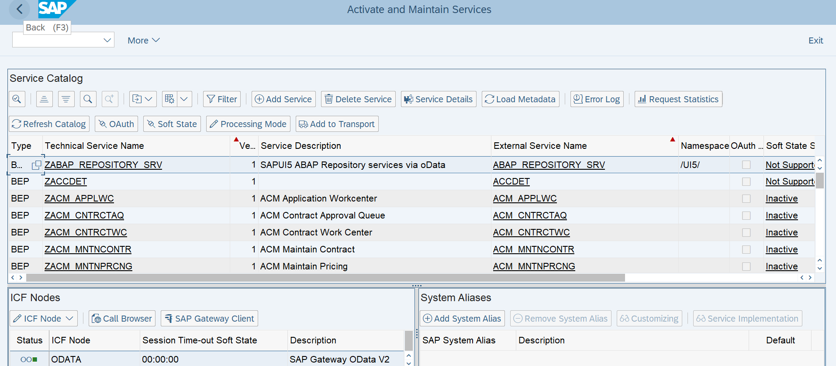
Now Click on Add Service and give the system alias as LOCAL and Service name as Z* to choose our Odata Service and then Click on Add Selected service to activate the ICF Node for the service
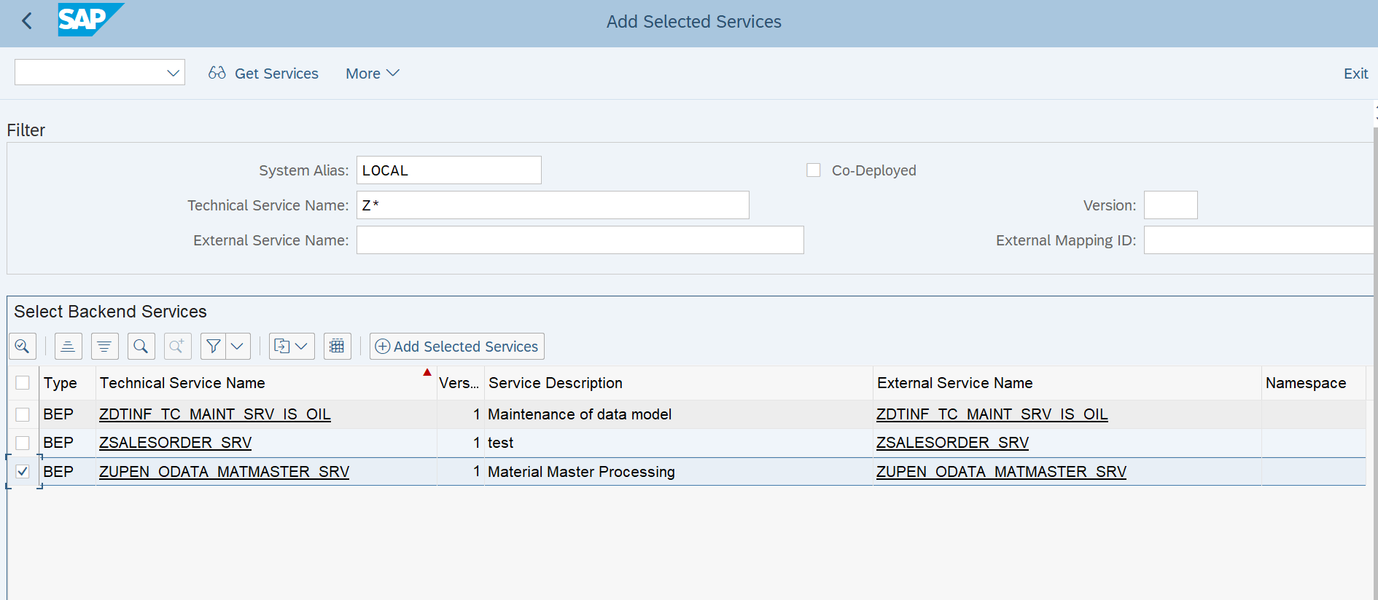
Now we can modify the technical service name and technical model name if required and then click on Enter and provide the TR for the ICF Service.
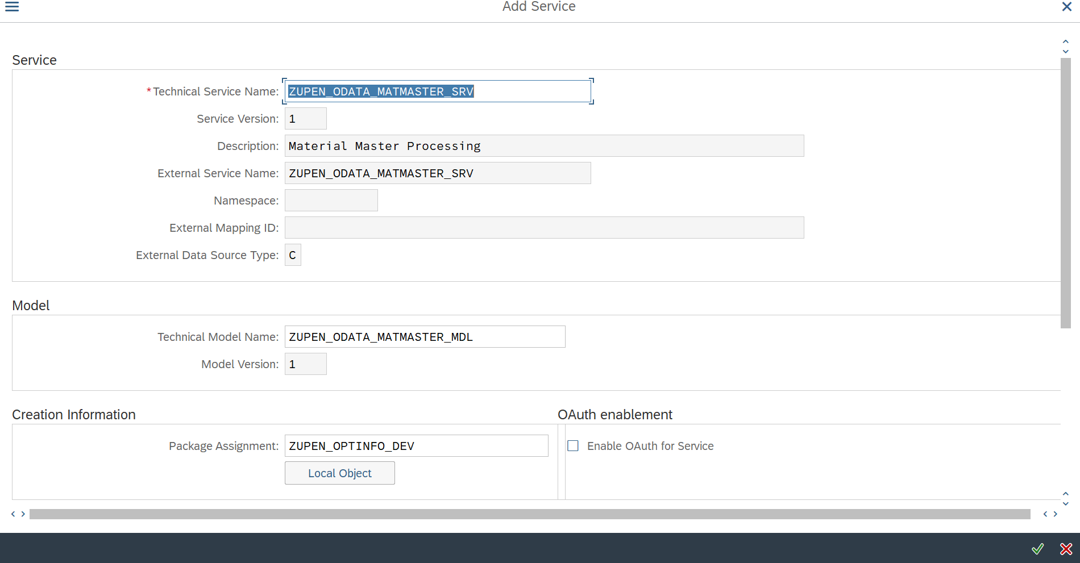
Now the Below Screen Will appear and in the ICF Nodes Section, Click on Configure SICF Button in the Drop down of ICF Node.
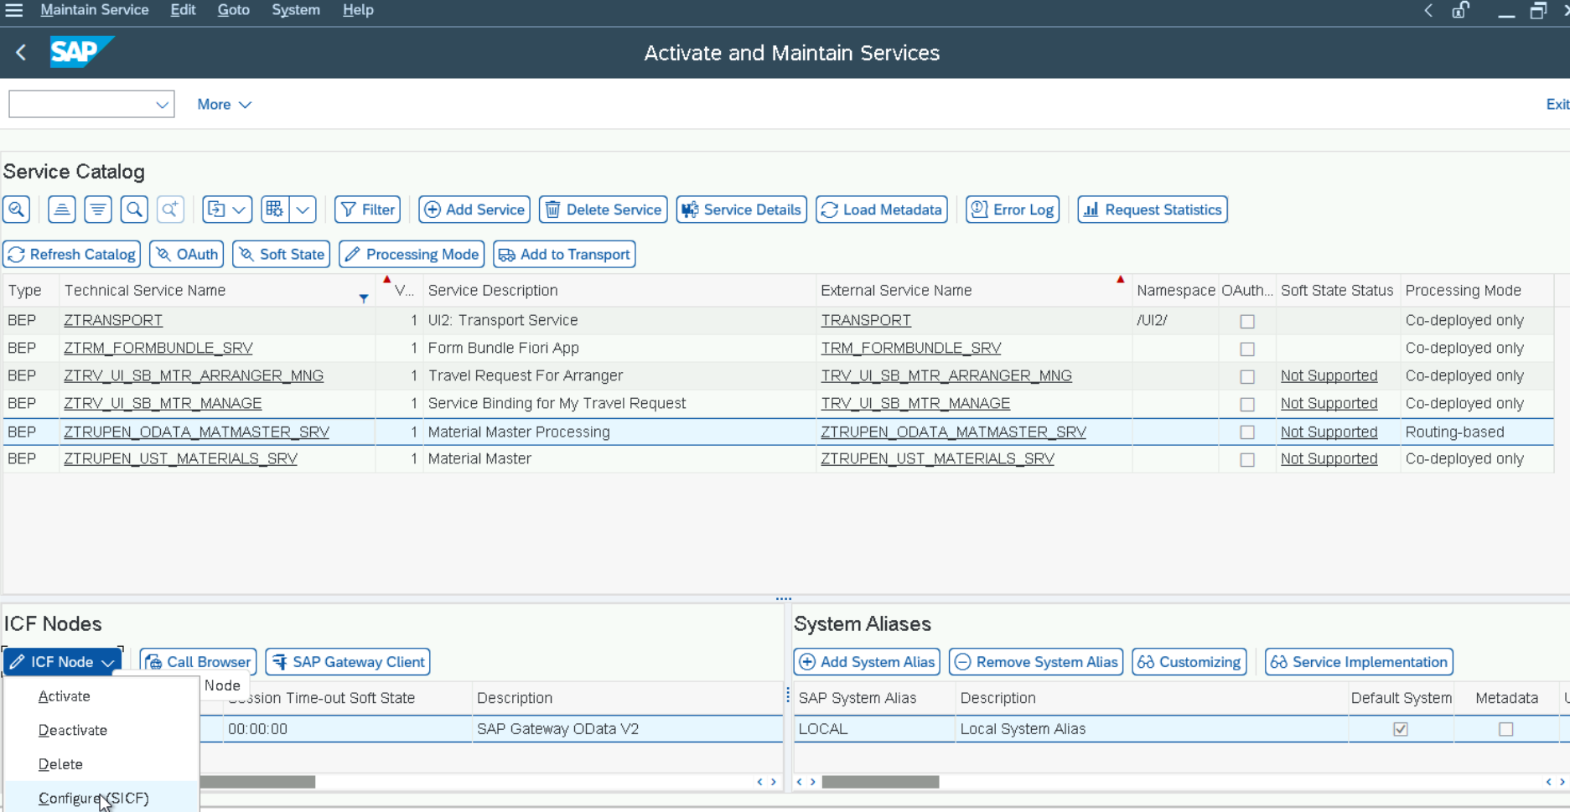
Now the Below screen will appear after clicking the Configure SICF button and double click on the Service now to check the ICF Node.
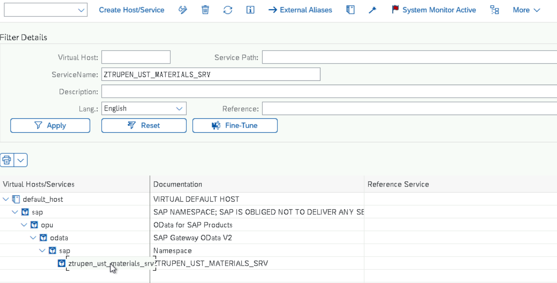
We can see the Service details now and Go in Change Mode and Click on the GUI Configuration Button in the Service Data section to add the parameter for disabling the CSRF Token Validation. (This step depends upon the system configuration and the CSRF Token Validation is enabled at the system level, we are disabling the CSRF token validation at the Service level to test the Gateway service from Gateway Client)
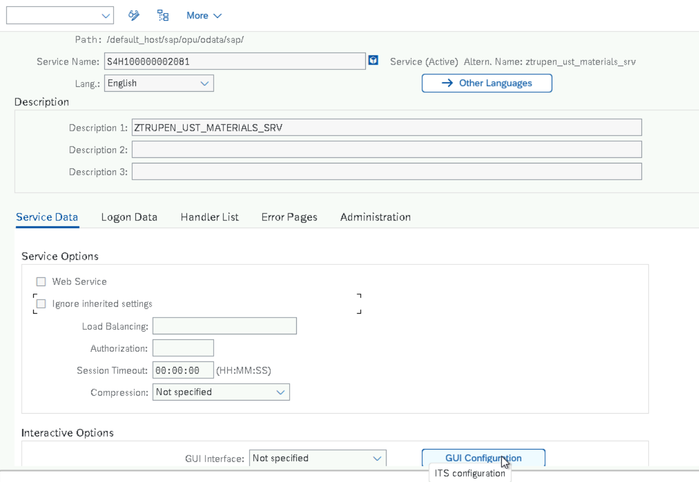
Now Maintain the Parameter name and value and click on Execute Button.
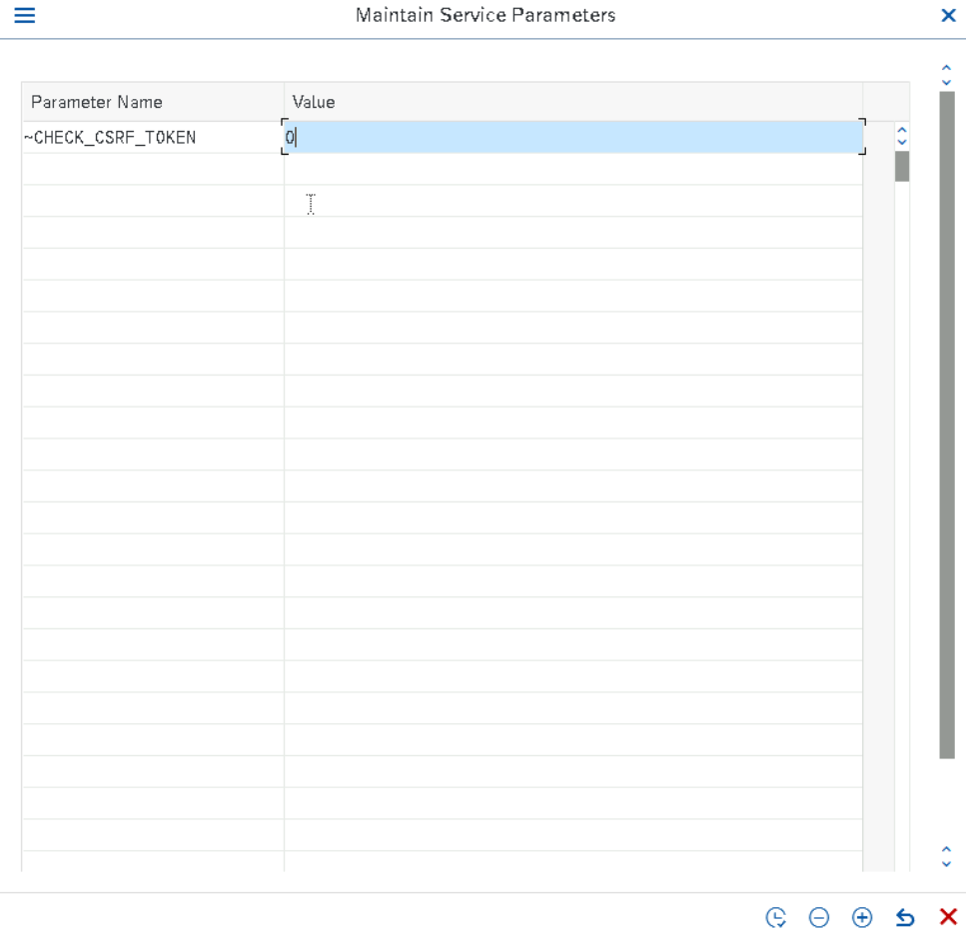
Upon saving the Service and the ICF node is activated for the service and CSRF Token Validation is Disabled
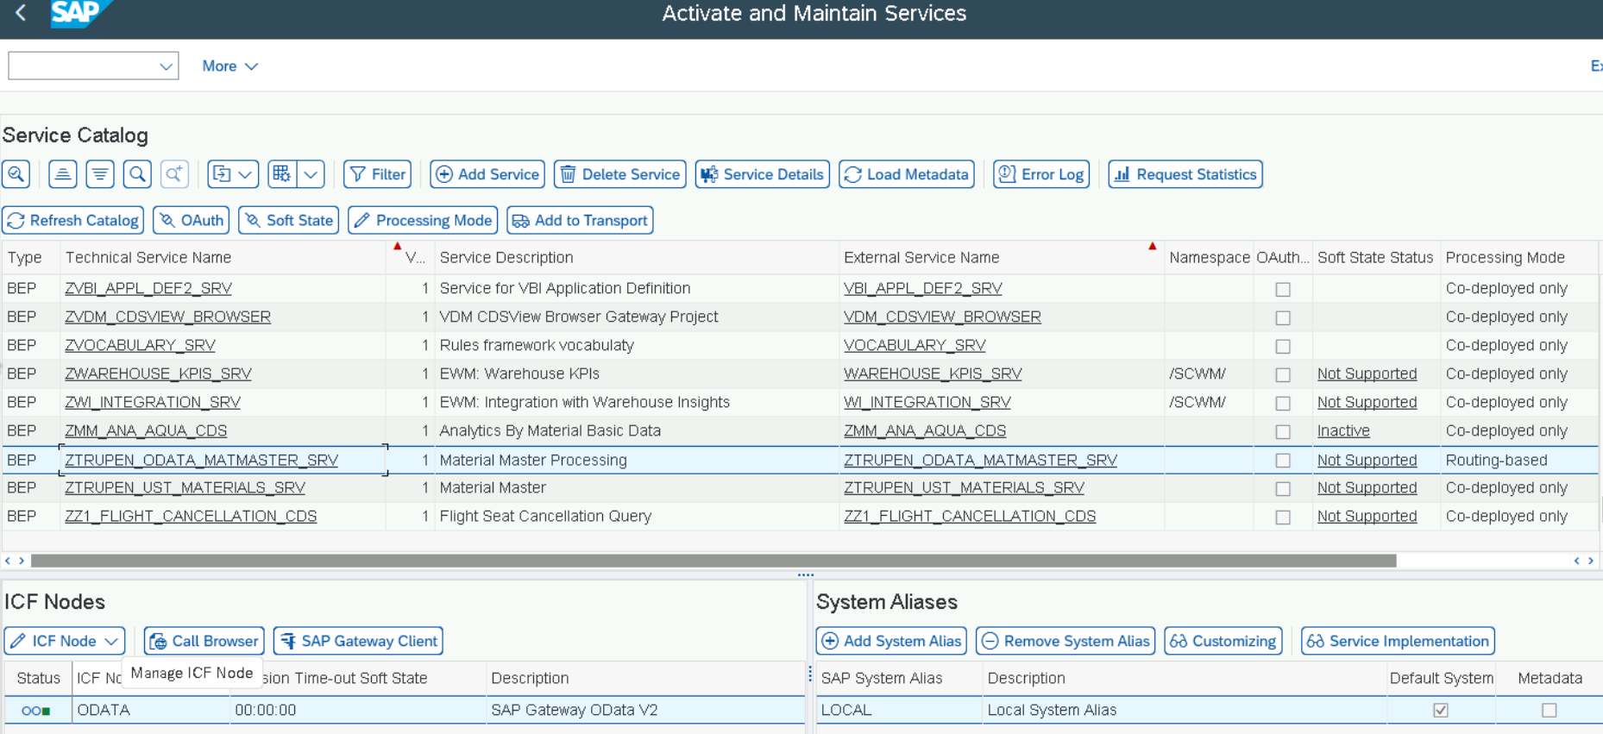
Now Click on SAP Gateway Client Button to check the Service which will open the Gateway Client to test the ODATA Service. This can be accessed directly through the Tcode /IWFND/GW_CLIENT and by mentioning the URI, we can start testing.
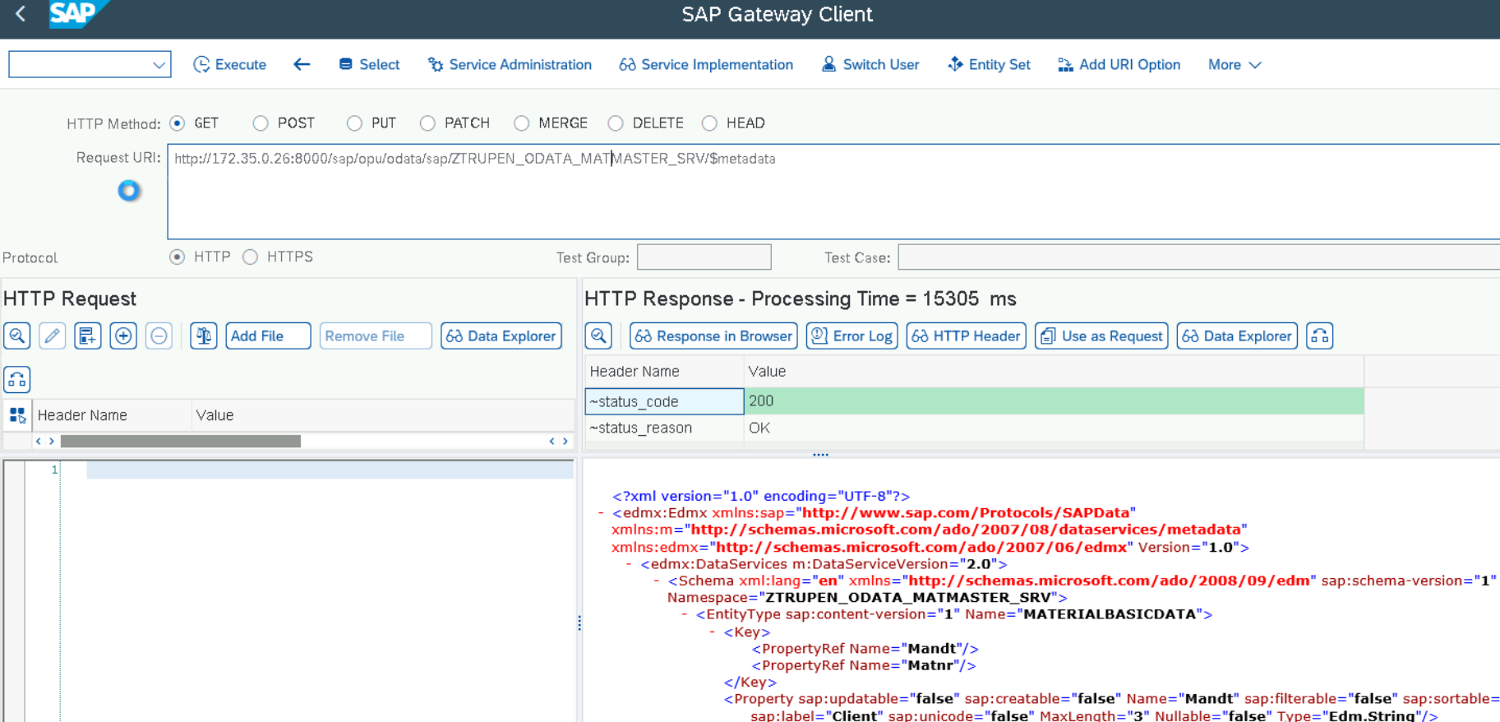
Testing Inputs
Choose the Corresponding HTTP Methods and pass the service and Entity details in the Request URI Section and Choose the Protocol as Http
GET -> Read Data
POST -> Create Data
PUT -> Update Data
DELETE -> Delete Data
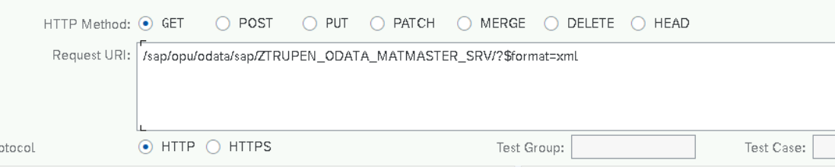
Now add the HTTP Request Header and body as shown below.
Add the content type as Json by Clicking on Add Header from value Help.
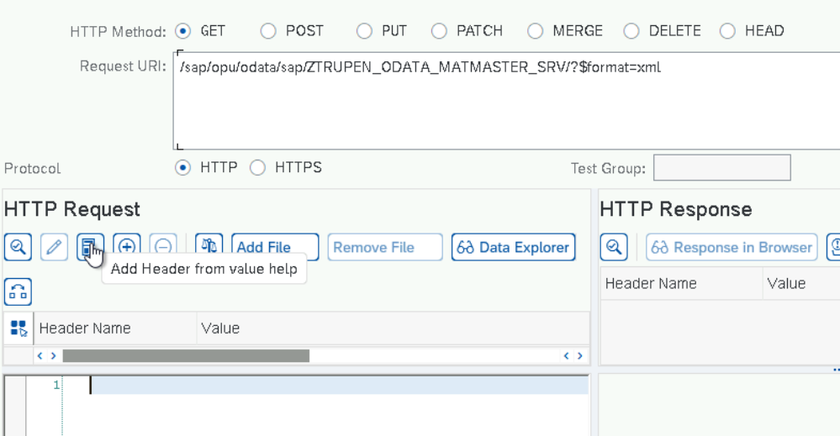
Now Click on Content-type in Header Name and Application/Json in Header Value and click on Enter.
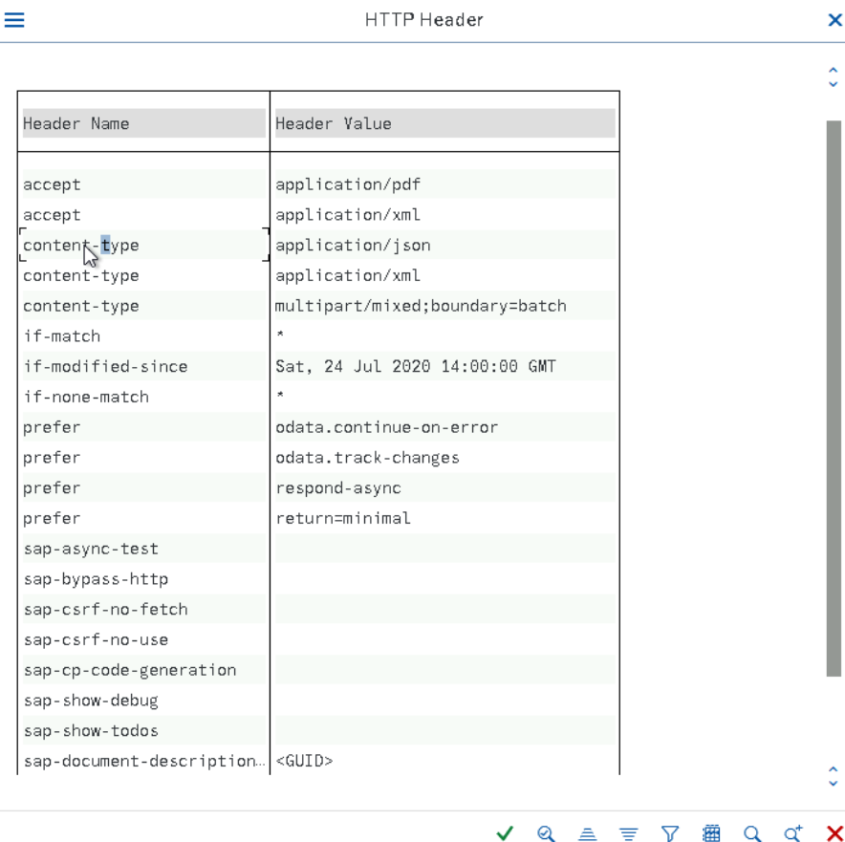
Similarly add Accept Application/Json to the HTTP Header to get the response in JSON Format.
In the Body Section, Pass the Field Inputs received during the Metadata Execution using the format “Key” : “value” pair Combination inside the open and close braces. Order of the field should match with the Same order of the fields defined in the Entity.
Format
{
“Fieldname1” : “Fieldname1Value”,
“Fieldname2” : “Fieldname2Value”,
……………………………………………………,
“FieldnameN” : “FieldnameNValue”
}
Examples
CREATE -Post
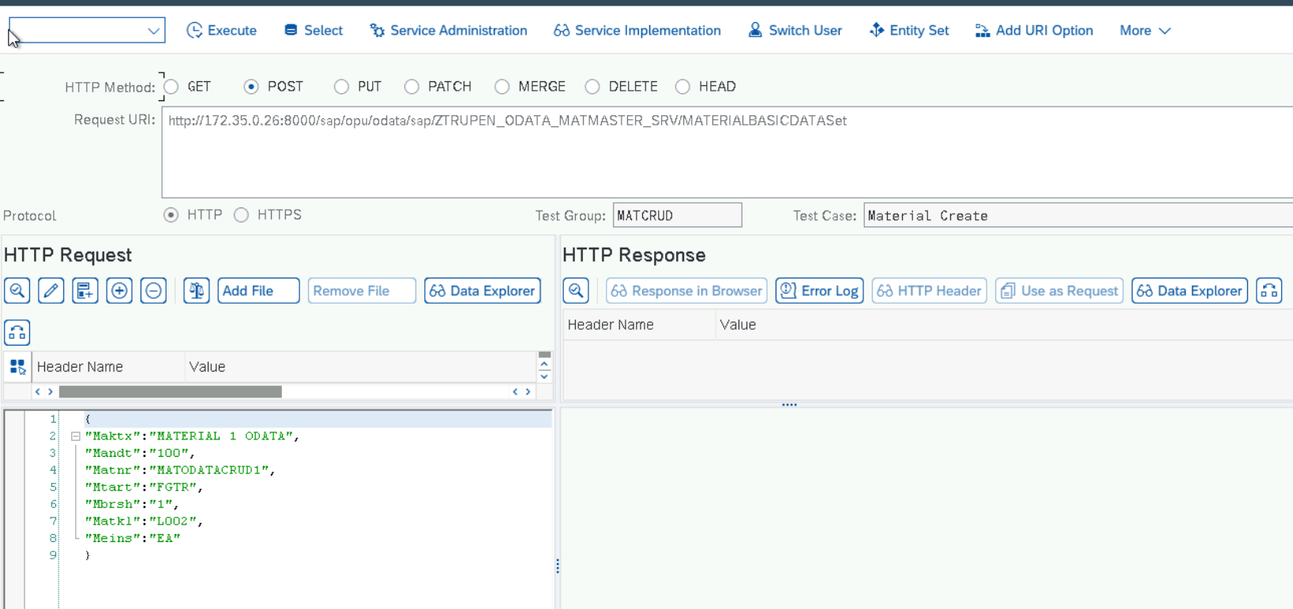
Update -Put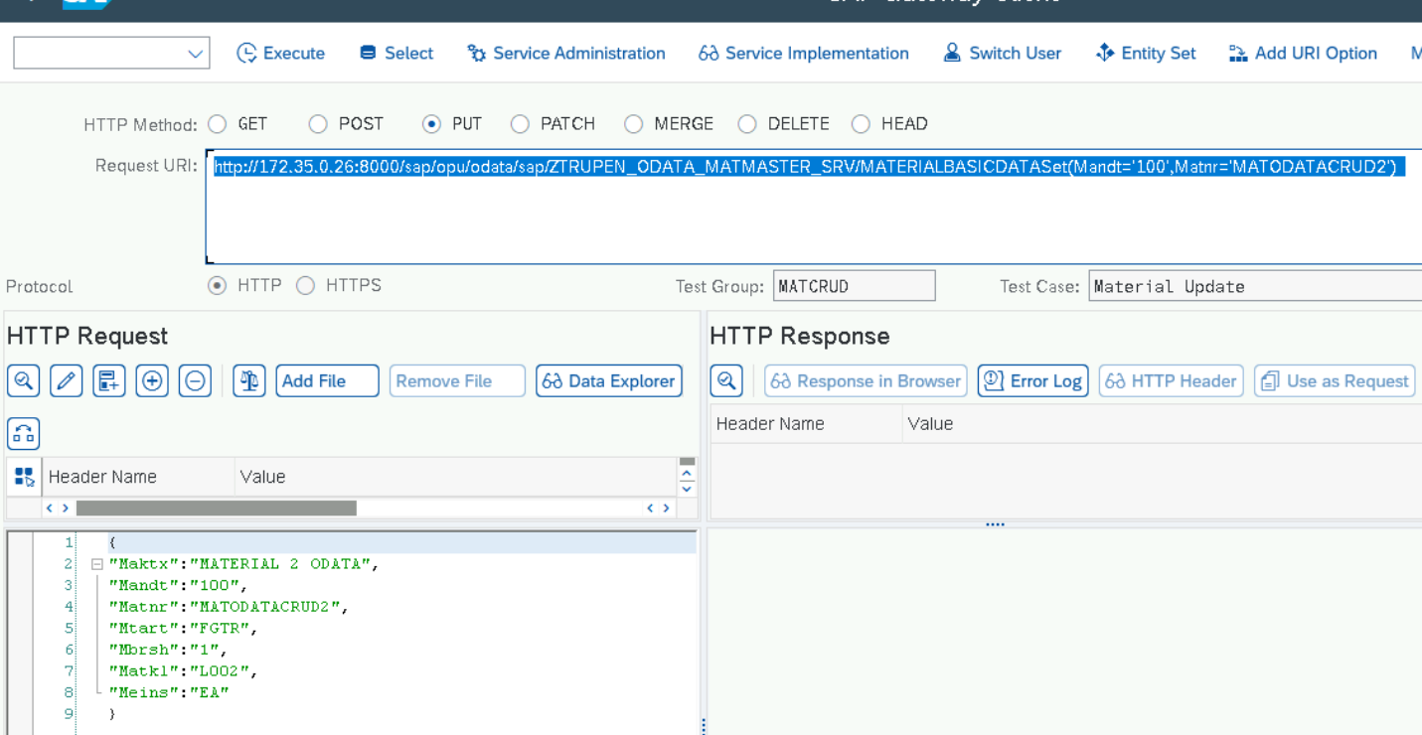
Delete - Delete
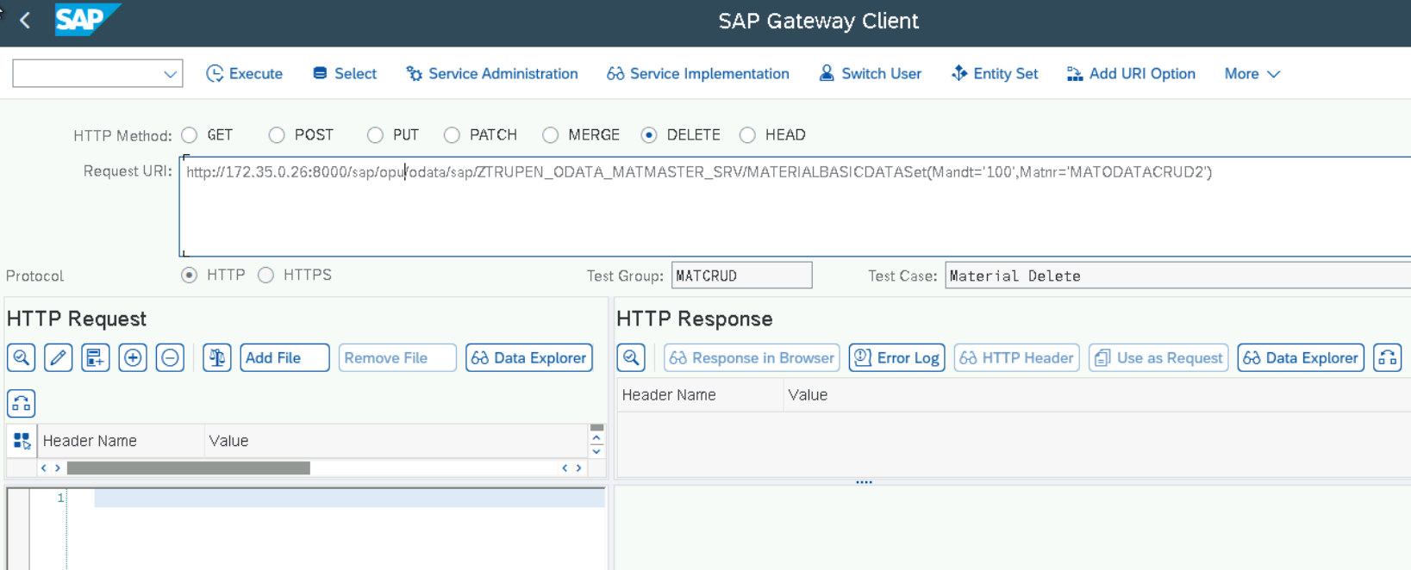
Read GET
